Document ID: | MEIRD-SOP-0046

SOP TITLE | Author | Reviewer | Approver
Raspberry Pi (User Manual) | Sagar/Prudhvi Raj | Manikanth | Jinwoo
Raspberry Pi (User Manual) | 29’08/07

 | Effective Date: | 29’08/07

Contents
1. Purpose 5
2. Scope 5
3. OS Installation 5
4. Package Installation 13
5. Prerequisites 26
6. Key generation 30
7. Hardware Set Up 34
8. Initial setup 36
9. User Procedure 37
10. Change History 41

Table of Figures
Figure 1 Raspberry Pi Imager Setup 6
Figure 2 Raspberry Pi Imager Window 6
Figure 3 Raspberry Pi Device Selection 7
Figure 4 Operating System Selection 7
Figure 5 Storage Selection 8
Figure 6 Selection Confirmation 8
Figure 7 OS Customisation Setting 9
Figure 8 Prompt for Erasing Contents of SD Card 9
Figure 9 Writing OS into Micro SD Card 10
Figure 10 Writing Completed 10
Figure 11 Raspberry Pi Peripheral connection 11
Figure 12 Welcome Prompt on Raspberry Pi 11
Figure 13 System Language Setting 12
Figure 14 Home Page on Raspberry Pi boot-up 12
Figure 15: Version Details in Terminal 13
Figure 16: Check for package updates 13
Figure 17: Python version check 14
Figure 18: Installing Python 14
Figure 19: Python Package Manager Installation 14
Figure 20: CAN library installation 15
Figure 21: CAN ISO TP Installation 15
Figure 22: UDS library installation 15
Figure 23: Python Installation 26
Figure 24: Download Visual Studio code 26
Figure 25: VS Code License agreement 27
Figure 26: Setup - VS Code 27
Figure 27: VS Code installed 28
Figure 28: Python Package in VS Code 28
Figure 29: Pandas installation 29
Figure 30: Openpyxl Installation 29
Figure 31: Security Access 33
Figure 32: Hardware Setup Connections 35
Figure 33: USB Connected prompt 36
Figure 34: Copy Source code into RaspberryPi 36
Figure 35:Source code folder structure 37
Figure 36: Input folders content 37
Figure 37: Main.py in Application folder 37
Figure 38: Services Database 38
Figure 39: UDS Config Editor 38
Figure 40: Menu in command prompt 39
Figure 41: Execution status 40
Figure 42: UDS Diagnostic report 40
Figure 43: UDS Debug log file 41

Purpose
The main purpose of a Standard Operating Procedure (SOP) is to provide clear and consistent instructions on how Common Diagnostics is implemented on Raspberry Pi Zero 2W board without any hustle. This template outlines the internal process to carry out such activities.

Scope
This document can be referred by the teams or individuals who performs or carry out the development of Common Diagnostics on Raspberry Pi Zero 2W activity.

OS Installation

Prerequisites
For Installation of OS on Raspberry Pi the necessary prerequisites are
- Personal Computer [with access to install a package]
- Micro SD Card [minimum 8GB of storage capacity]
- A card reader [in the case PC has no slot for Micro SD card]
- Raspberry Pi Zero 2W board
- Power Supply connection [a socket with 230V AC power supply running, a Power Adapter with 2.5A/5V power output rating, a USB-A to micro-USB cable to connect from Adapter to the board]

OS installation into MicroSD Card
The procedure for setting up the imager needs a personal computer with windows, macOS or Ubuntu operating system. This SOP document uses a windows operating system for performing OS installation into microSD card.

Imager Installation on Windows
Imager is an application that helps write OS into target storage drive.
Download the imager from the Raspberry official webpage. In this SOP the demonstration uses windows operating system. Open the imager for windows and allow permission to install.
The window as shown below comes up.
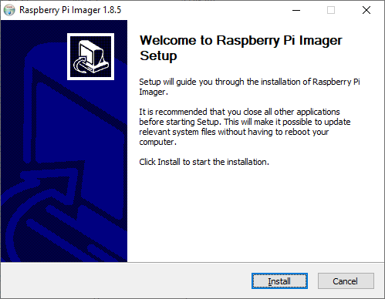
Figure 1 Raspberry Pi Imager Setup
Click on Install button and wait until setup is completed. Check the Run Raspberry Pi Imager box and click on Finish to open the imager.

Copying OS into Micro SD card
Raspberry Pi Imager application window opens after clicking on Finish button while Run Raspberry Pi Imager box is ticked.
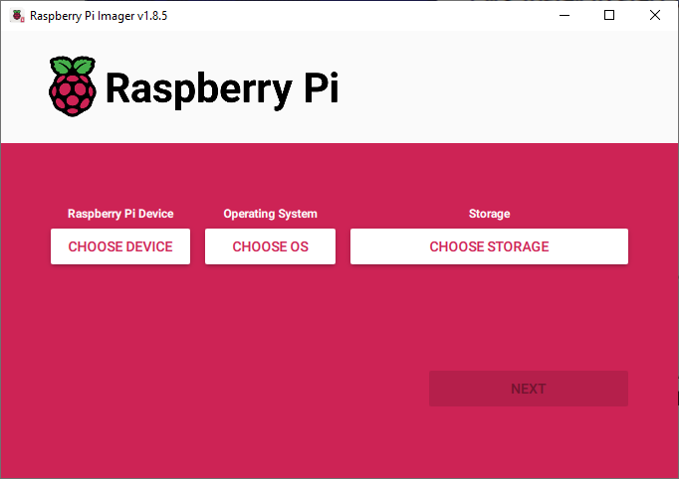
Figure 2 Raspberry Pi Imager Window
This SOP uses Raspberry Pi Zero 2W board, so select on choose device under Raspberry Pi Device and click on Raspberry Pi Zero 2W option.
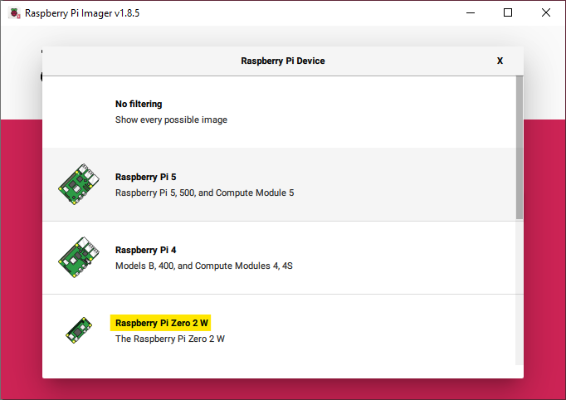
Figure 3 Raspberry Pi Device Selection
Now select on choose OS under Operating System and click on Raspberry Pi OS (64-bit) option.
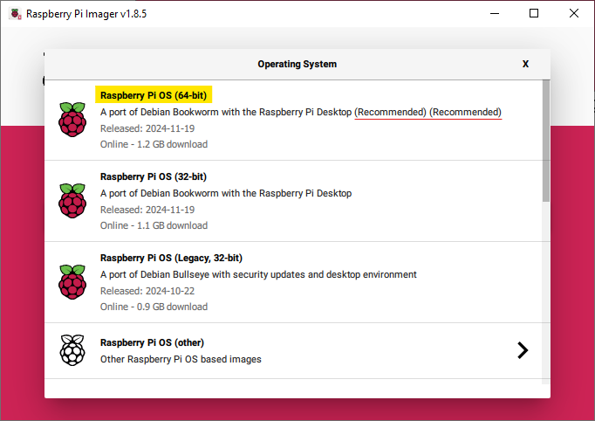
Figure 4 Operating System Selection
Now select on choose storage under Storage and click on the driver that shows the Micro SD card details. [Assure that you chose correct storage driver]
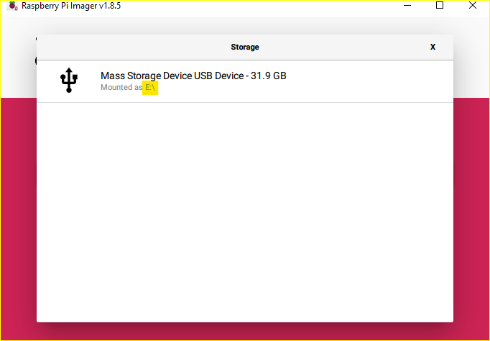
Figure 5 Storage Selection
Recheck whether the selection made is correct.
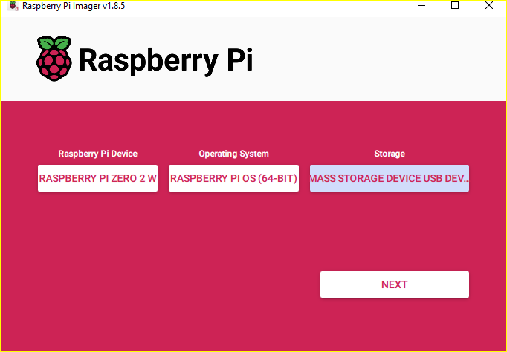
Figure 6 Selection Confirmation
Now click on Next option.
If Customisation of OS is needed, then click on Edit Settings else on No option.
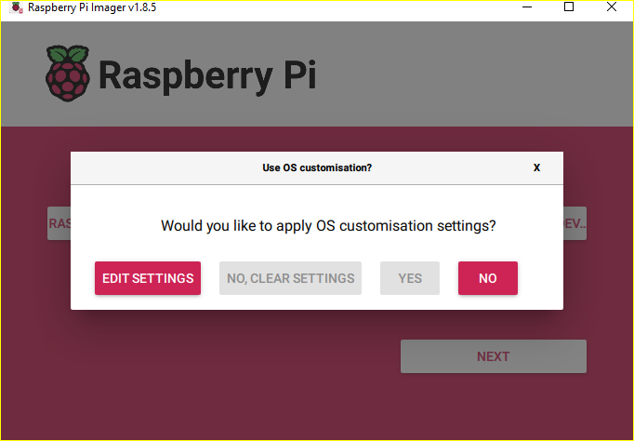
Figure 7 OS Customisation Setting
[In this demo, No is selected] Then a prompt asking confirmation to erase the contents of Micro SD Card before writing OS into it. Click on Yes.
Note: Make sure that the Micro SD card has no important data as after formatting the data can’t be retrieved.
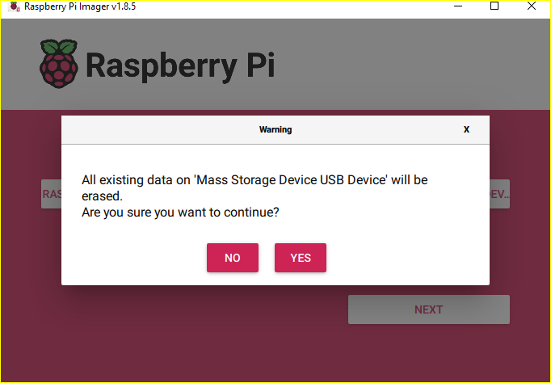
Figure 8 Prompt for Erasing Contents of SD Card
This will erase the contents of the Micro SD card. On completion of erasing then OS is written into it.
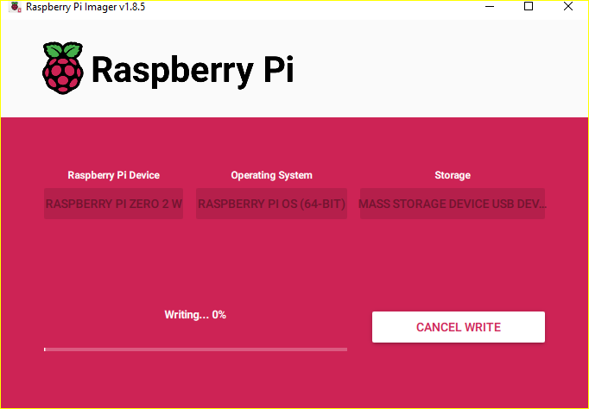
Figure 9 Writing OS into Micro SD Card
Click on Continue on completion of writing. Then remove Micro SD Card from PC.
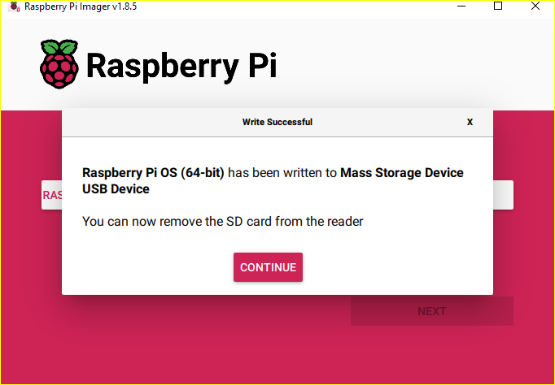
Figure 10 Writing Completed

Setting up Raspberry Pi Board

Connect the Hardware
Connect Power Supply, Monitor, Keyboard and Mouse to the raspberry Pi Board ports. Insert the Micro SD card with OS copy into the slot provided on the board.
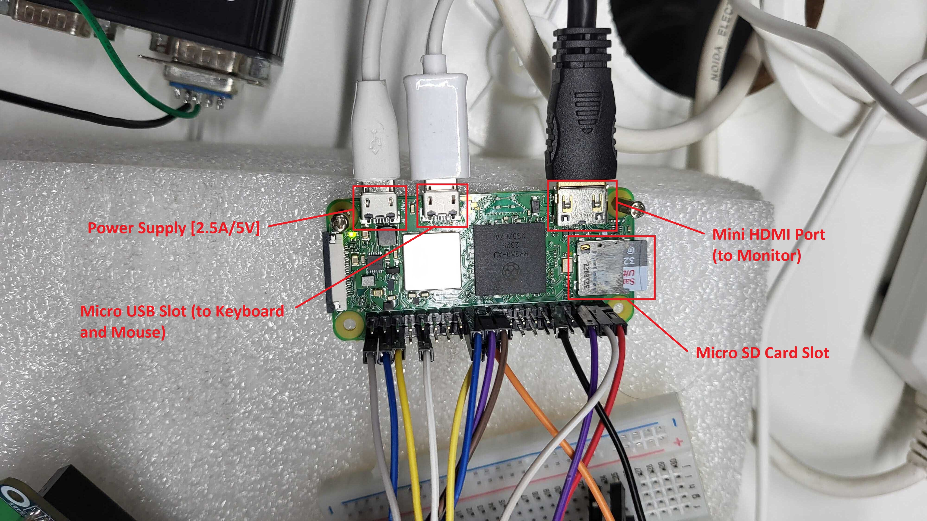
Figure 11 Raspberry Pi Peripheral connection
Now switch on the power for both Raspberry Pi and Monitor. A welcome prompt greets on the monitor. Click on Next.
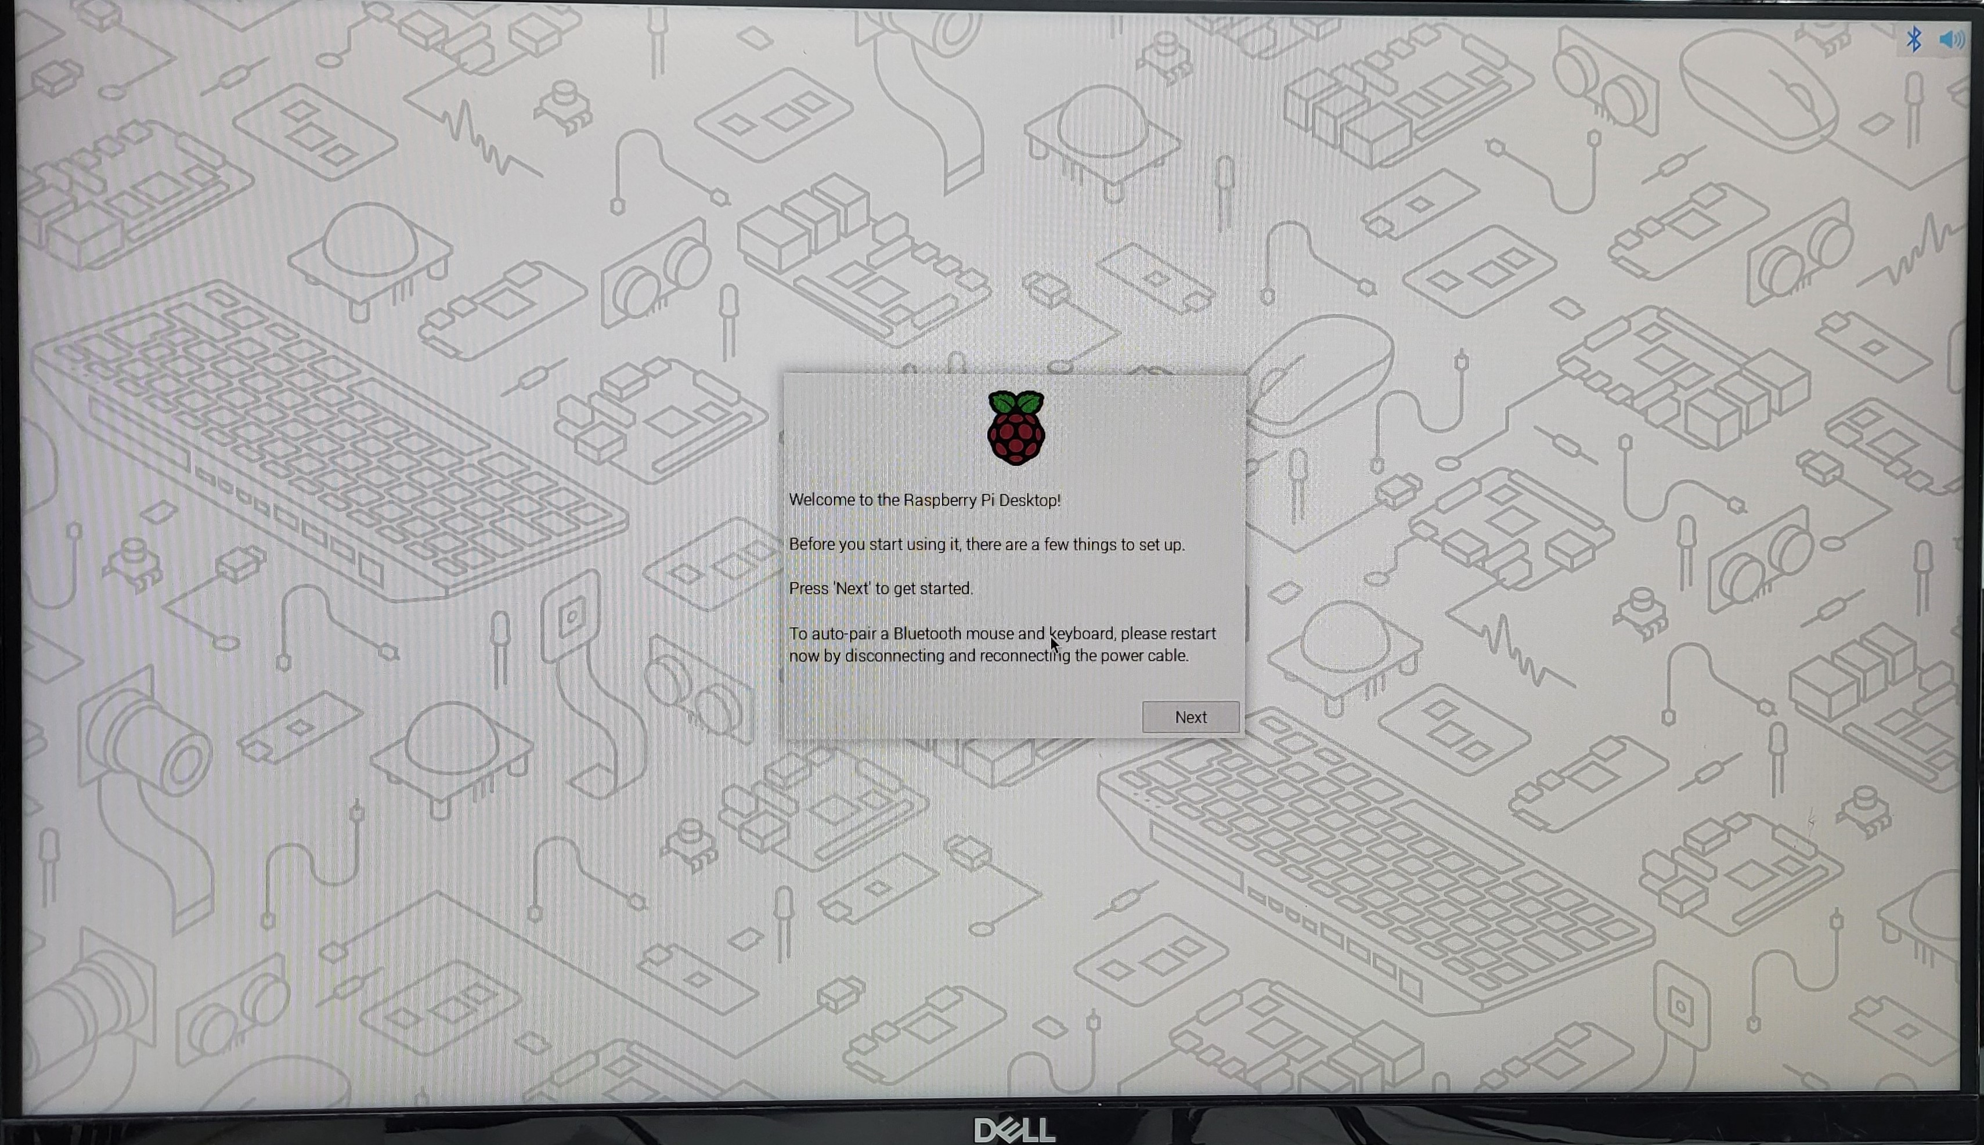
Figure 12 Welcome Prompt on Raspberry Pi

Then comes a window with options to choose Country, Language and Timezone. Select suitable options [for demo Country: India, Language: English, Timezone: Calcutta are chosen] and click on Next.
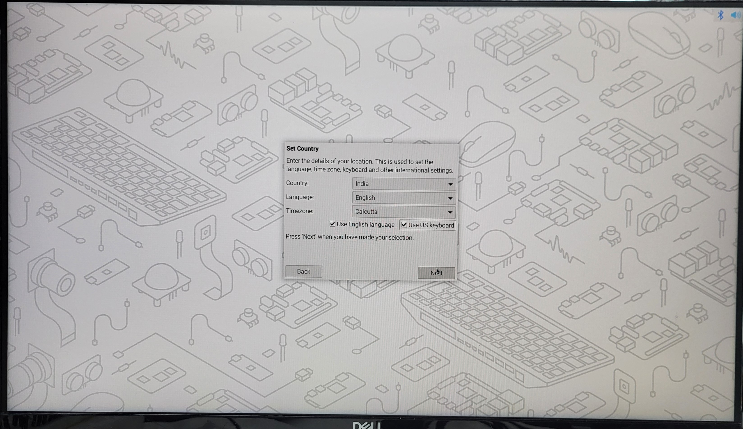
Figure 13 System Language Setting

Raspberry Pi OS on successful boot gives the below shown home page.
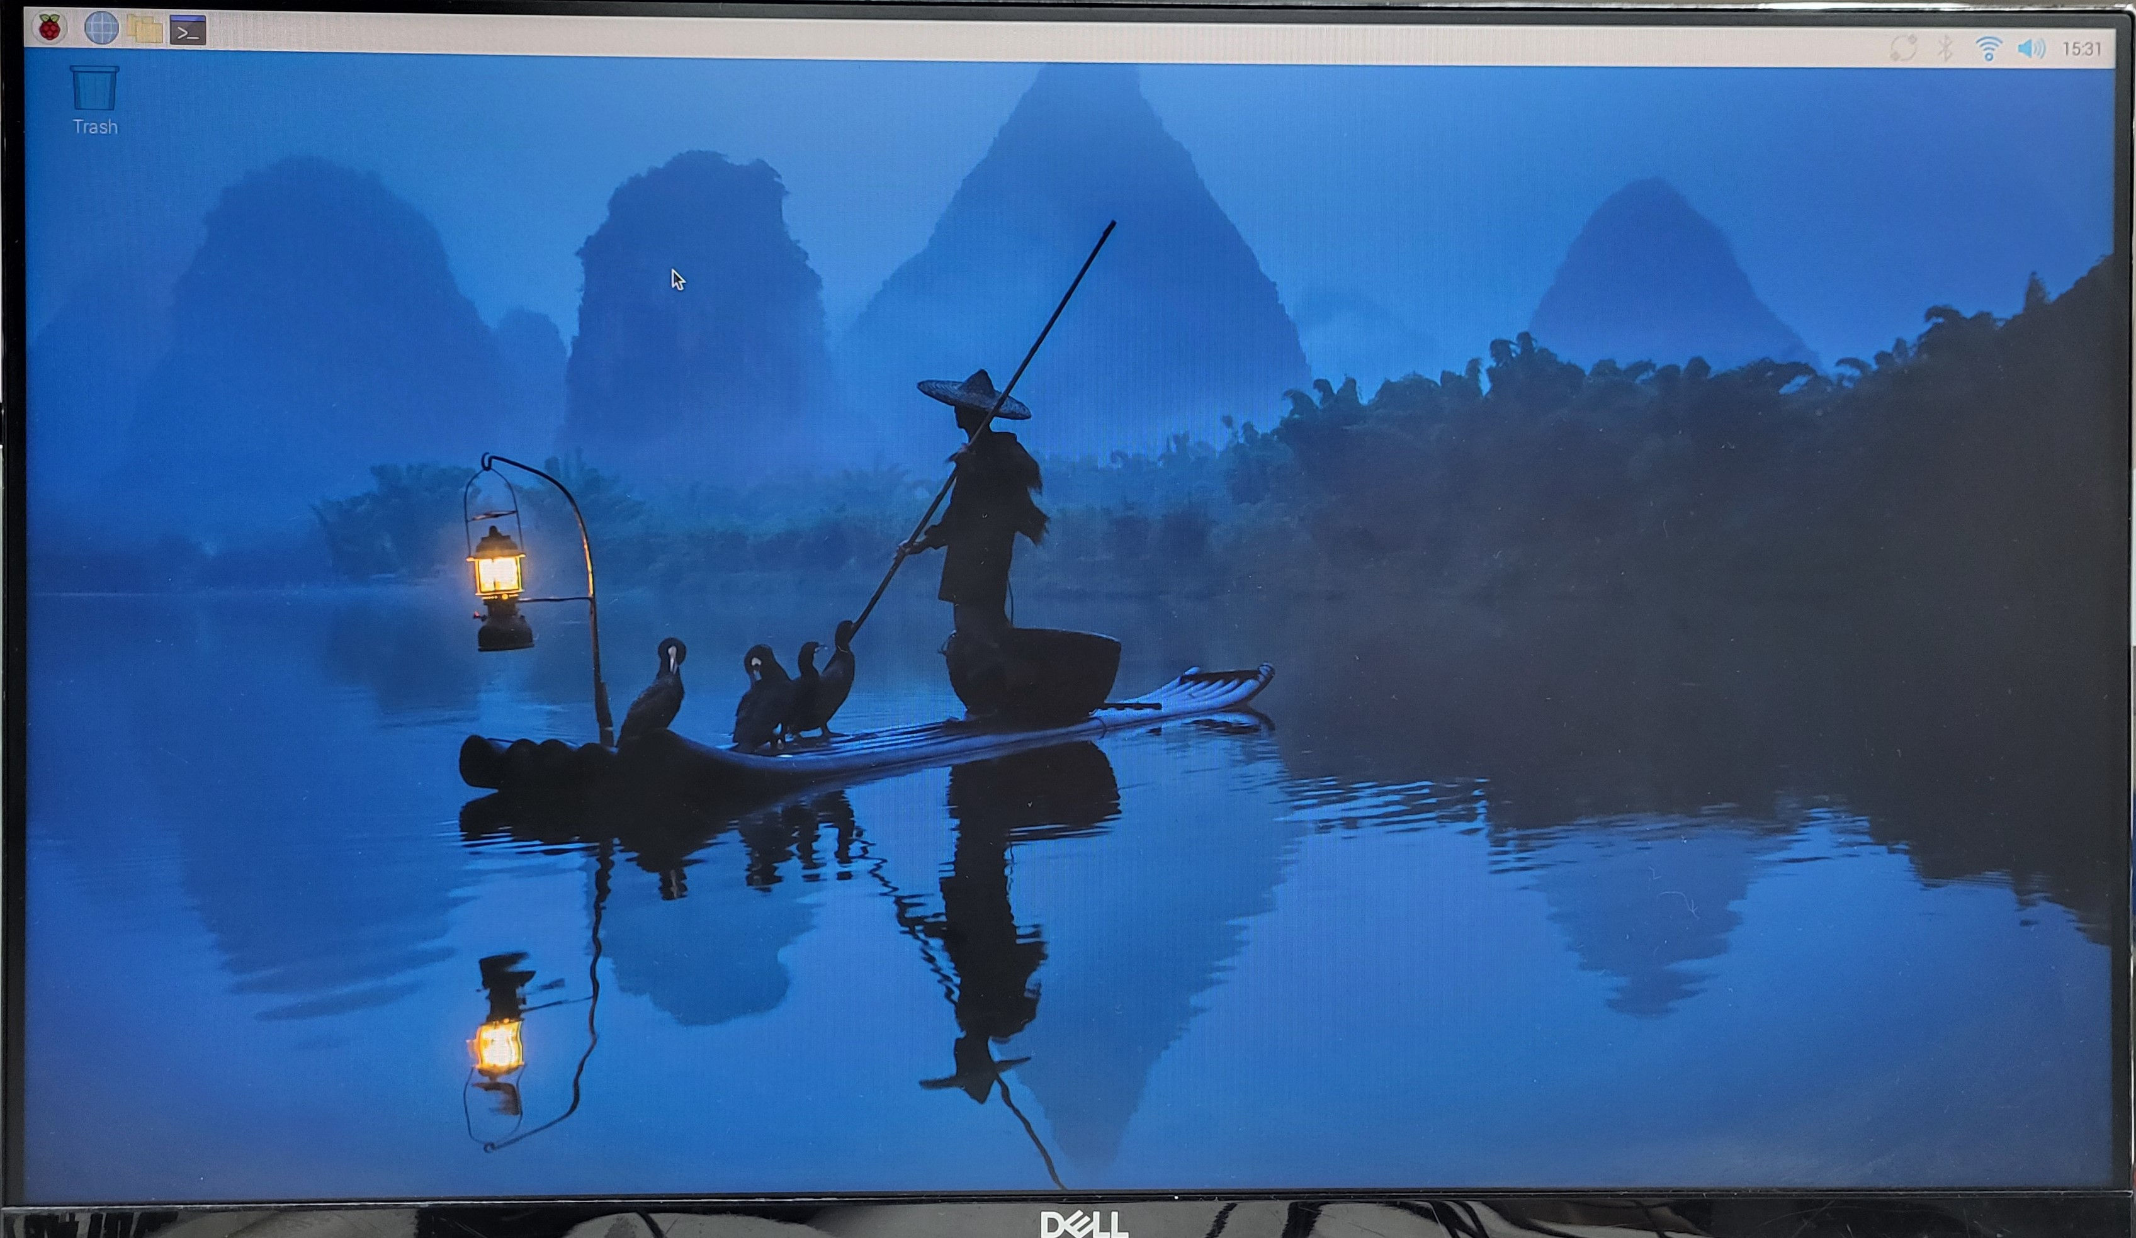
Figure 14 Home Page on Raspberry Pi boot-up
This document can be referred by the teams or individuals who performs or carry out the Installation

Confirmation of Successful Installation
To confirm whether the installation is successful open the terminal and run the following commands. Observe the terminal for the version details.
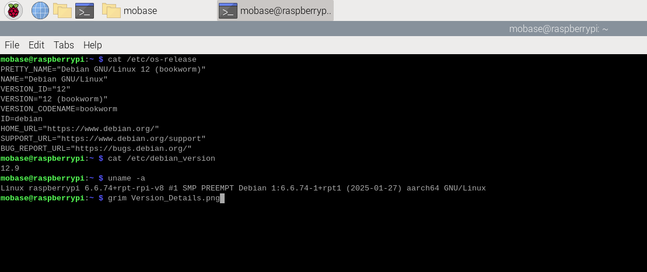
Figure 15: Version Details in Terminal

Package Installation

Prerequisites
For Installation of libraries on Raspberry Pi the necessary prerequisites are
- Raspberry Pi Zero 2W with Raspberry Pi OS installed.
- Internet connection.

Updating the System
Before installing any packages, update the system to ensure all installed components are up to date.
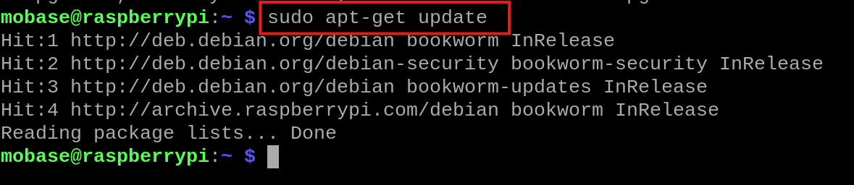
Figure 16: Check for package updates

Python Installation
Python and pip (Python package manager) are required for most packages
Python is pre-installed on Raspberry Pi Zero 2W. You can verify this by running the following command:
- python3 –version
- pip3 –version
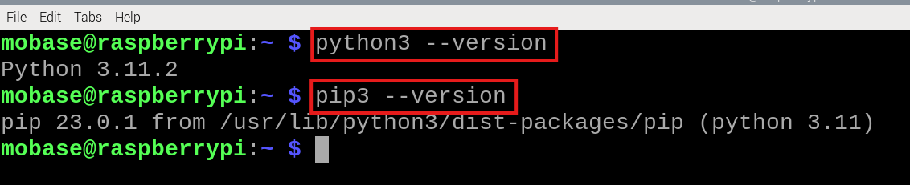
Figure 17: Python version check

If not installed, then install it by running the following command:
- sudo apt install python3
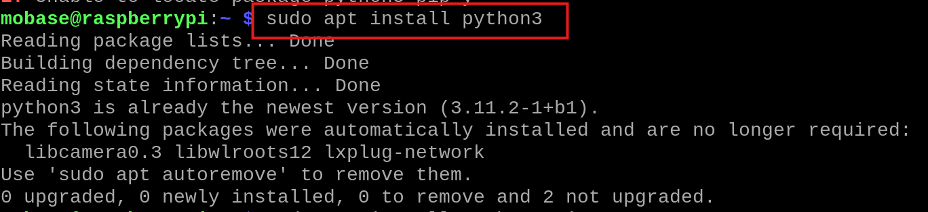
Figure 18: Installing Python

- sudo apt install python3-pip
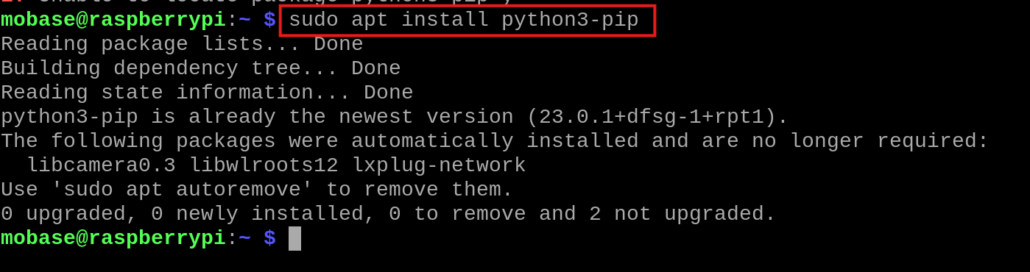
Figure 19: Python Package Manager Installation

Packages for RS485_CAN_HAT

Install Required Packages
For installation errors, refer to section 4.8 for troubleshooting.
- Python-can (for CAN bus communication): Used to interface with CAN buses in Python. It allows sending, receiving, and logging CAN messages
Install it using the command: sudo apt-get install python3-can
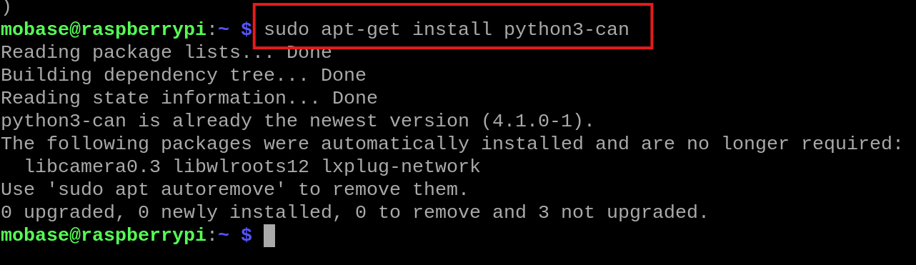
Figure 20: CAN library installation

- ISOTP: Used to handle ISO-TP (ISO Transport Protocol) over the CAN bus. It is required when sending or receiving multi-frame CAN messages.
Install it using the command: pip install can-isotp

Figure 21: CAN ISO TP Installation

- UDSONCAN: Used to implement the UDS (Unified Diagnostic Services) protocol over CAN networks, allowing communication with ECUs to send diagnostic requests, manage sessions, and decode responses.
Install it using the command: pip install udsoncan

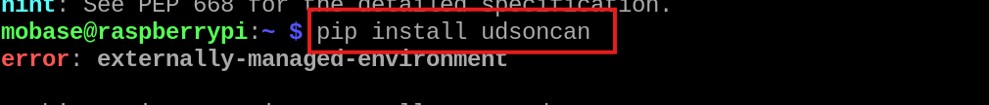
Figure 22: UDS library installation

Enabling SPI in raspi-config
Enable SPI Interface:
- Open the terminal and run the command.
- command: sudo raspi-config
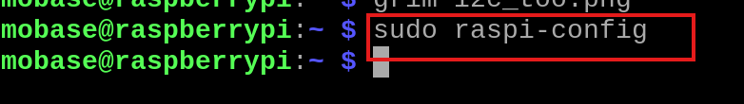
- Navigate to Interface Options → SPI → Select Yes to enable it
- Interface Options
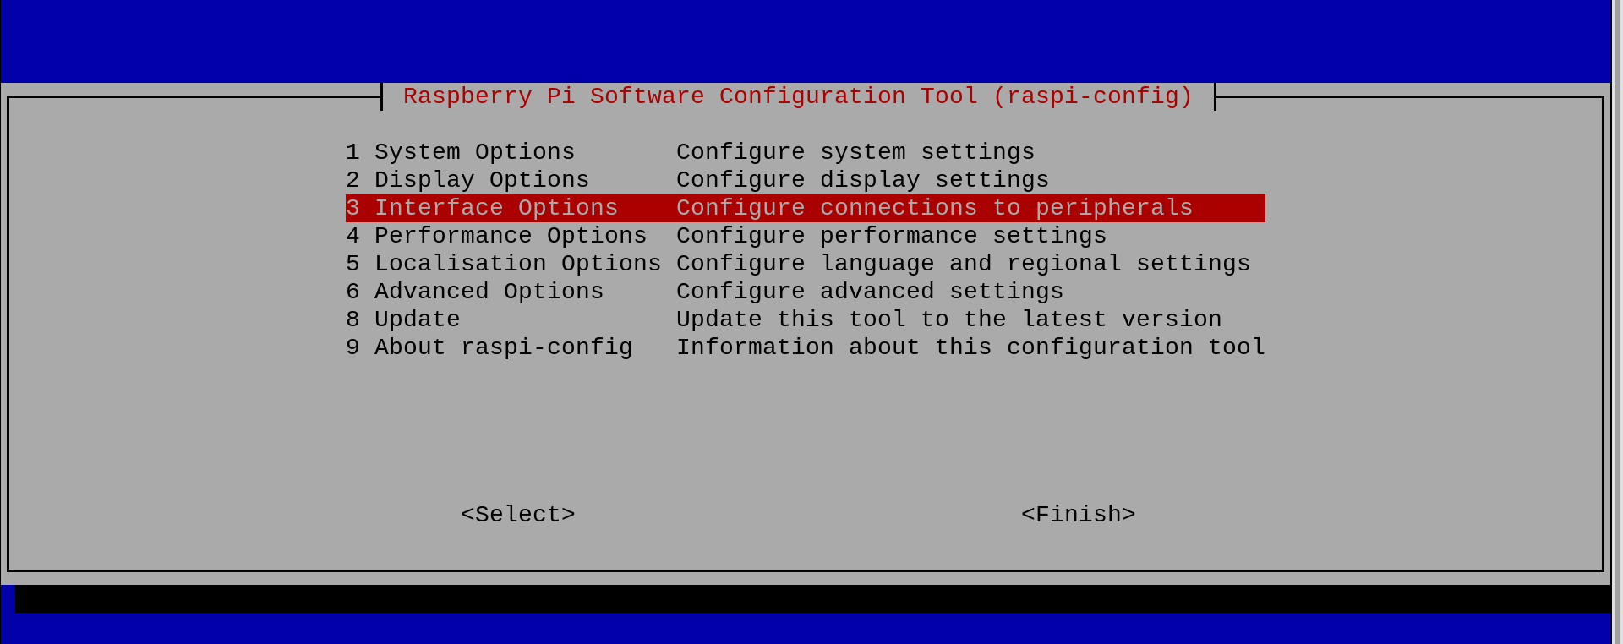
- SPI
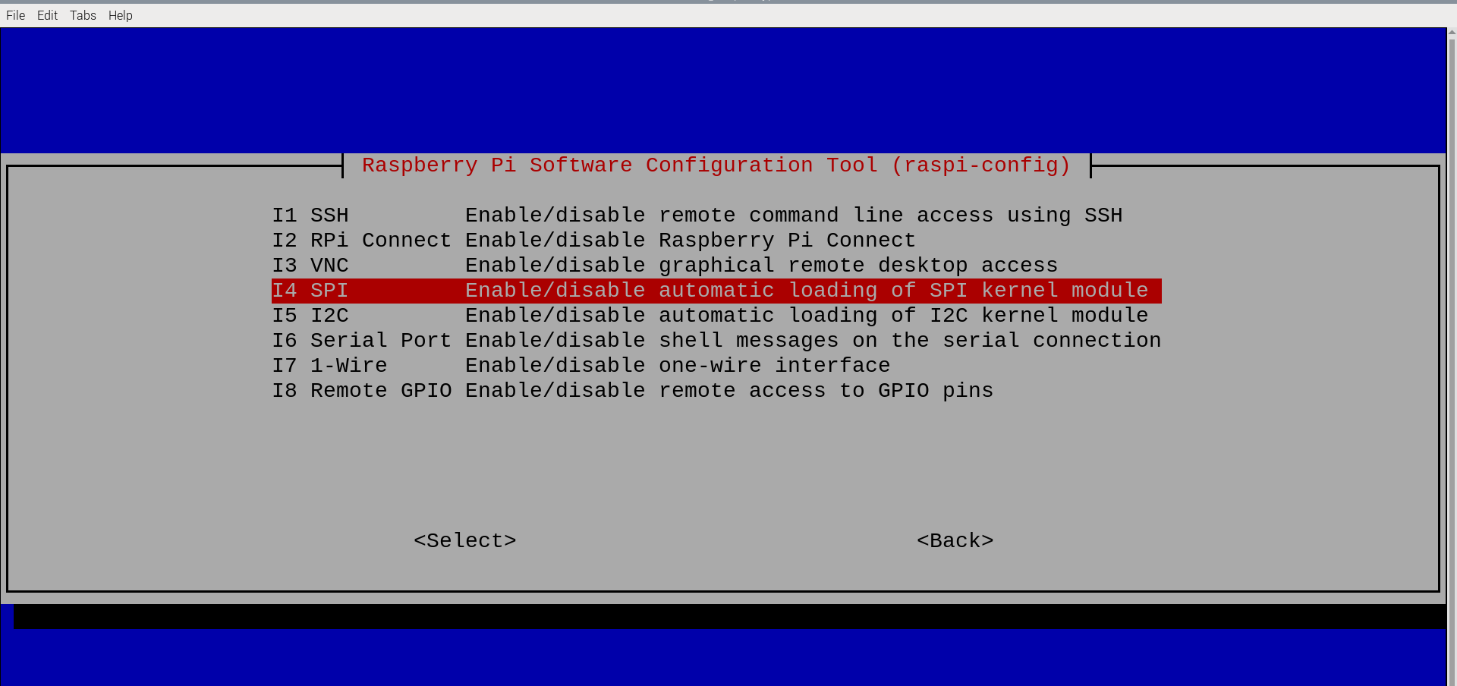
- Select Yes and press Enter to enable it.
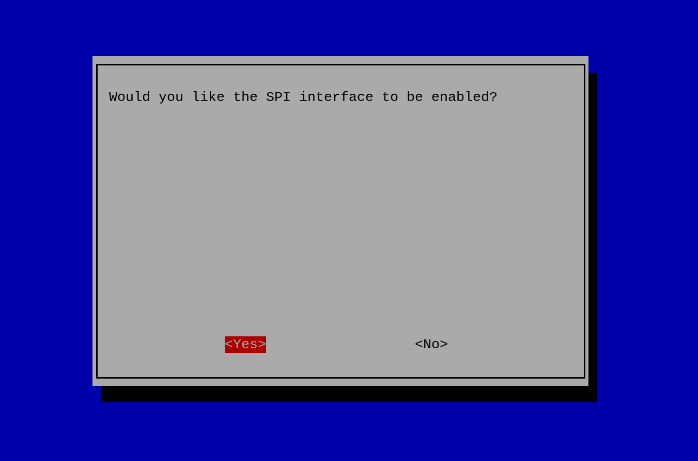

- Select Ok and press Enter
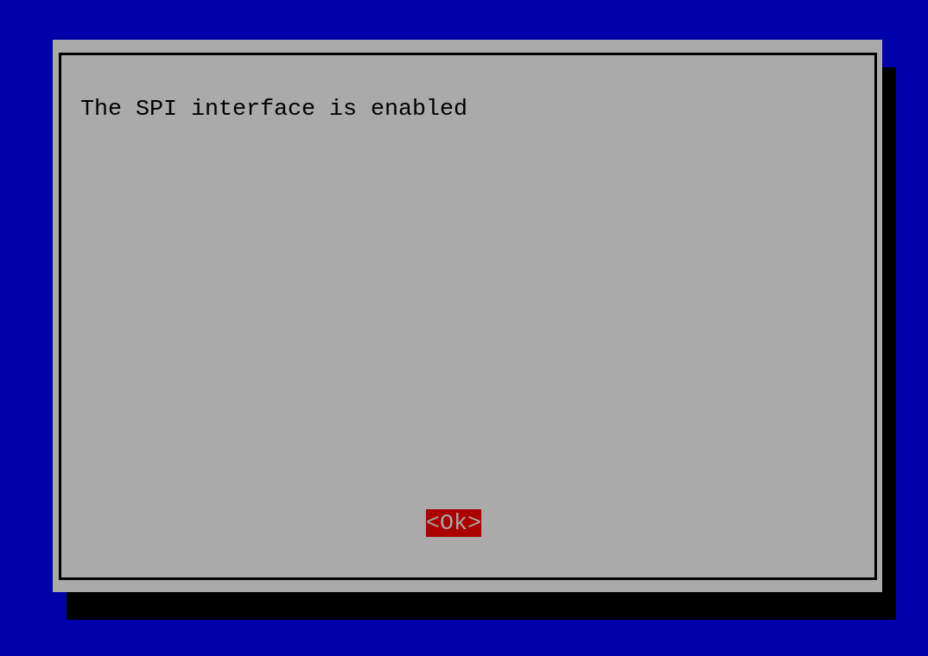

- Select Finish and press Enter
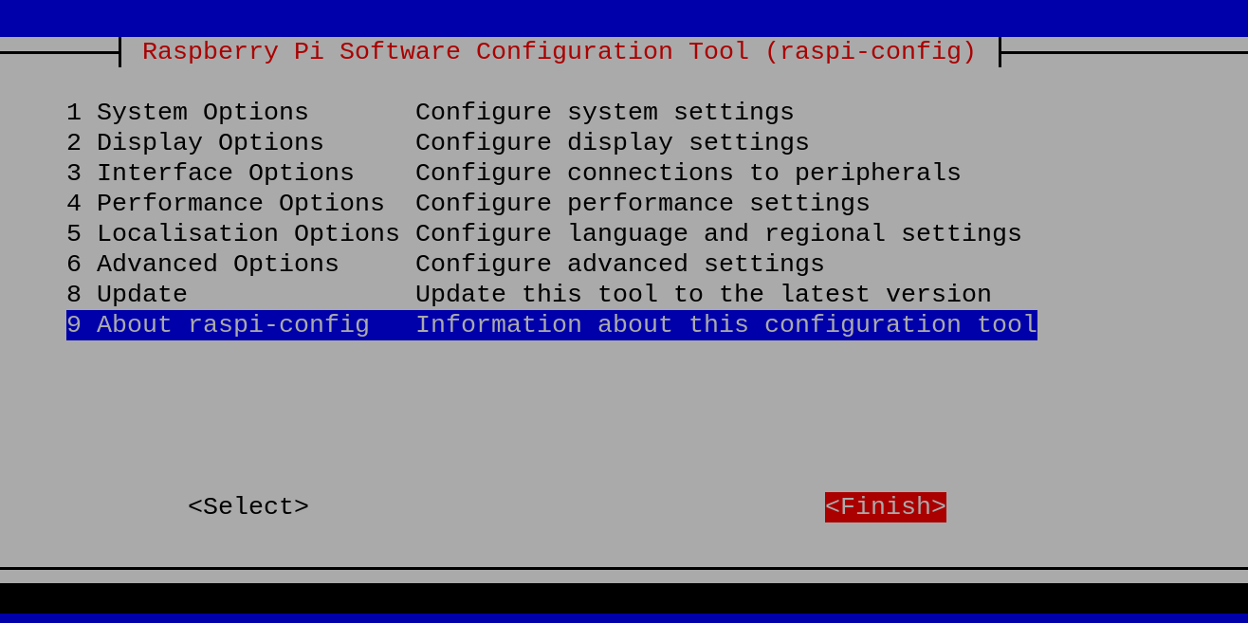

Configuring config.txt
The config.txt file must be modified to enable CAN interfaces or adjust settings.
To edit it, follow these steps.
- Run the command: sudo nano /boot/firmware/config.txt
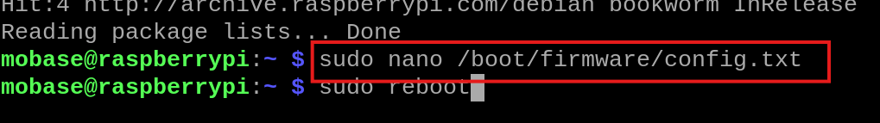

- Add the following lines to the config.txt file to enable the CAN interface:
FOR RS485_CAN_HAT:
- Enable SPI by adding the following line:
    - dtparam=spi=on

- Enable the CAN bus by adding:
    - dtoverlay=mcp2515-can0,
oscillator=12000000, interrupt=25, spimaxfrequency=2000000
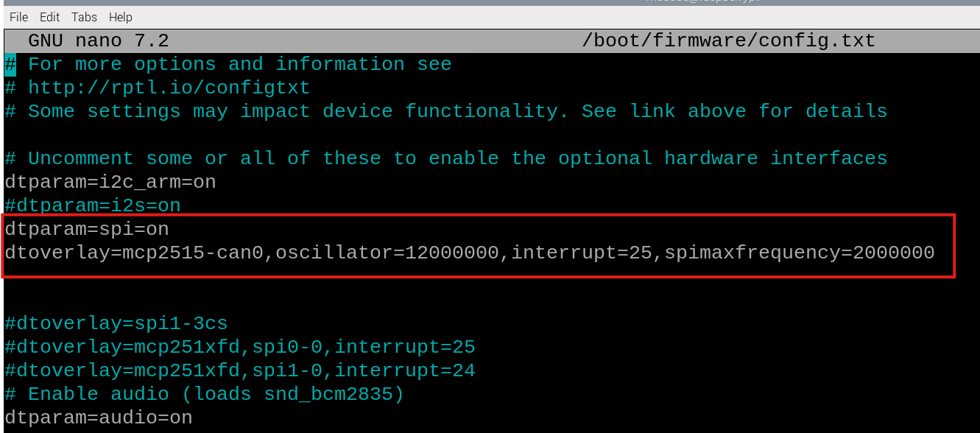

- Save the changes and exit (Press`CTRL+X`, then `Y`, then `Enter`).
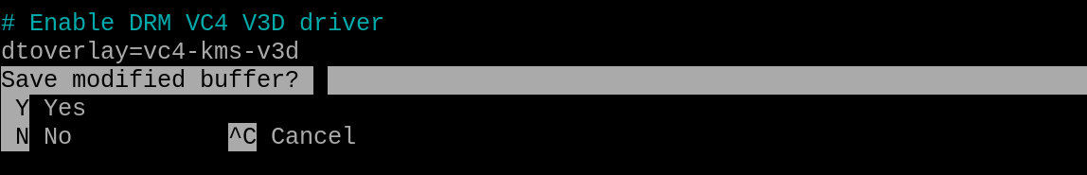

- Reboot the system for the changes to take effect:
- Run the command: sudo reboot
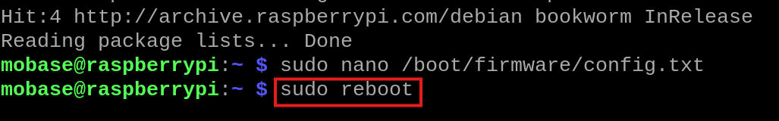

Setting Up and Verifying the CAN Interface
- Run the following commands to configure and bring up the CAN interface.
- We can activate the CAN interface and configure the CAN bus speed to 500 kbps using the command below:
Command: sudo ip link set can0 up type can bitrate 500000

- We can set the transmit queue length for the CAN interface using the command below:
Command: sudo ifconfig can0 txqueuelen 65536
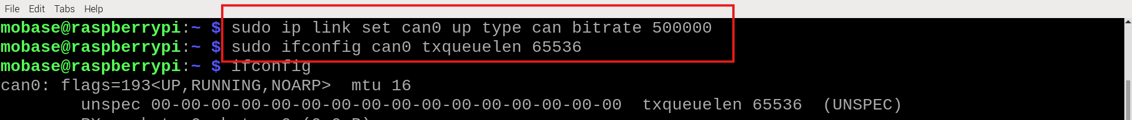
- After setup, you can check the CAN interface status with:
- We can check the CAN interface status after setup using the command below:
Command: ifconfig
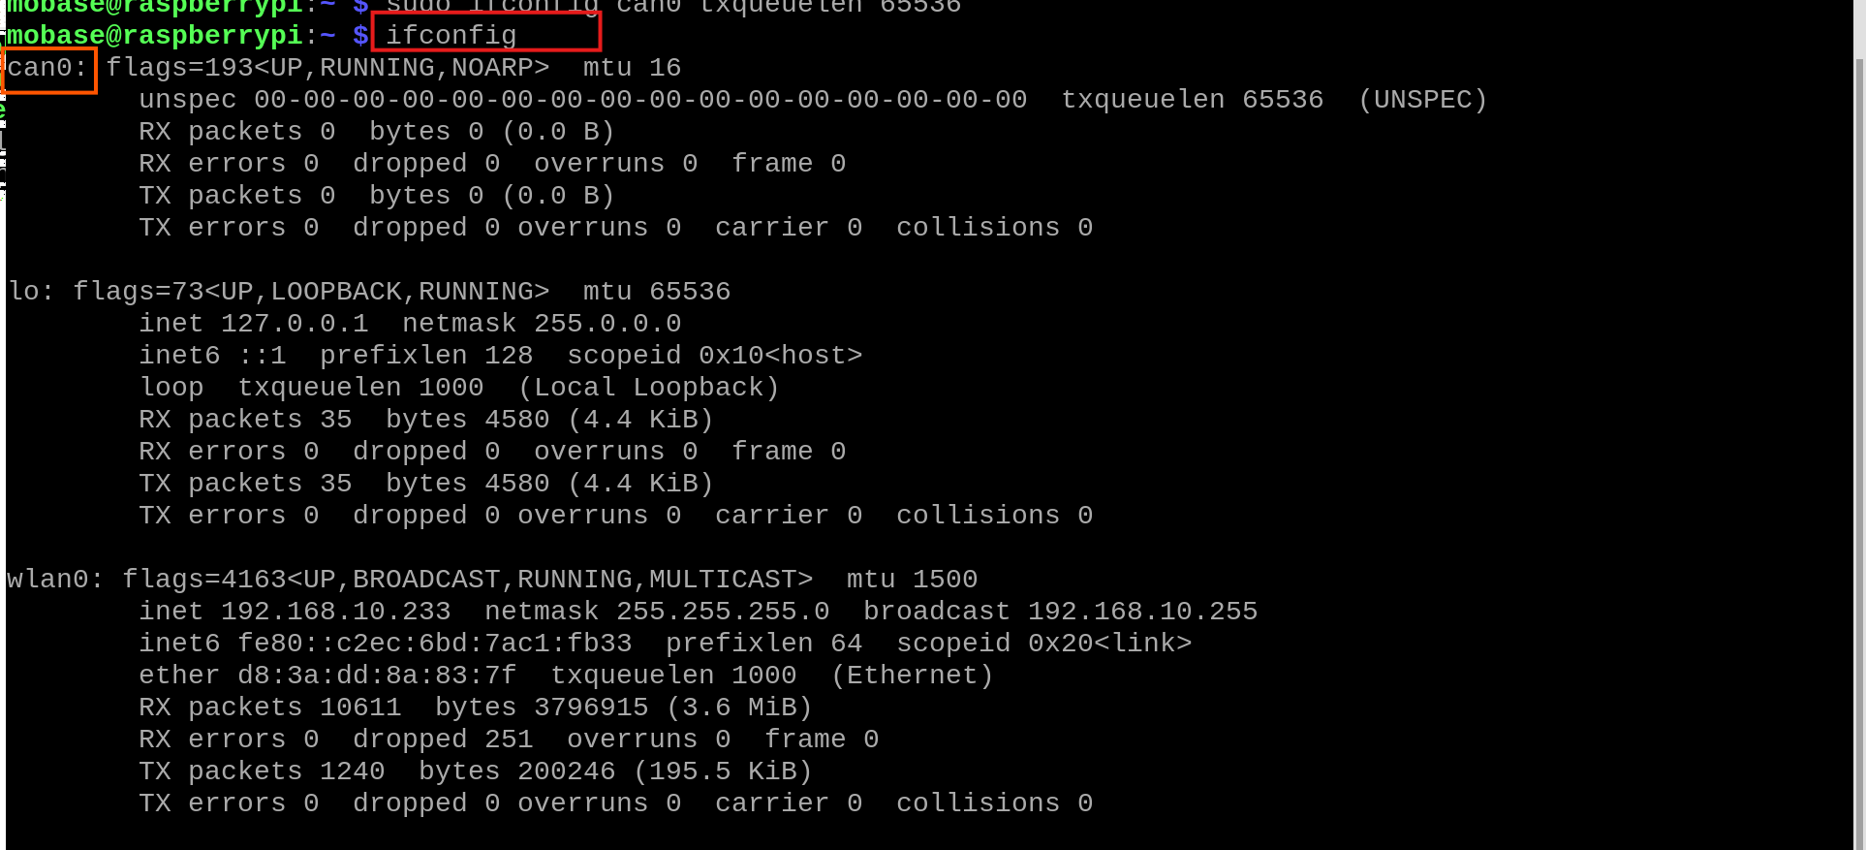

Packages for 2-CH_CAN_FD_HAT
The installation process for the 2-CH CAN FD HAT follows the same steps as the RS485 CAN HAT module, as described in sections 4.4.1 and 4.4.2.
First, the required packages must be installed, and then SPI should be enabled via the raspi-config tool to ensure proper communication with the CAN bus interface.

Configuring config.txt
The config.txt file must be modified to enable CAN interfaces or adjust settings.
To edit it, follow these steps.
- Run the command: sudo nano /boot/firmware/config.txt

- Add the following lines to the config.txt file to enable the CAN interface:
FOR 2-CH_CAN_FD_HAT:
- Enable SPI by adding the following line:
- dtparam=spi=on

- Enable SPI1 with three chip select (CS) lines:
- dtoverlay=spi1-3cs

- Enable the CAN bus by adding:
- Configure MCP251XFD CAN FD controller on SPI0:
- dtoverlay=mcp251xfd, spi0-0, interrupt=25

- Configure MCP251XFD CAN FD controller on SPI1:
- dtoverlay=mcp251xfd, spi1-0, interrupt=24
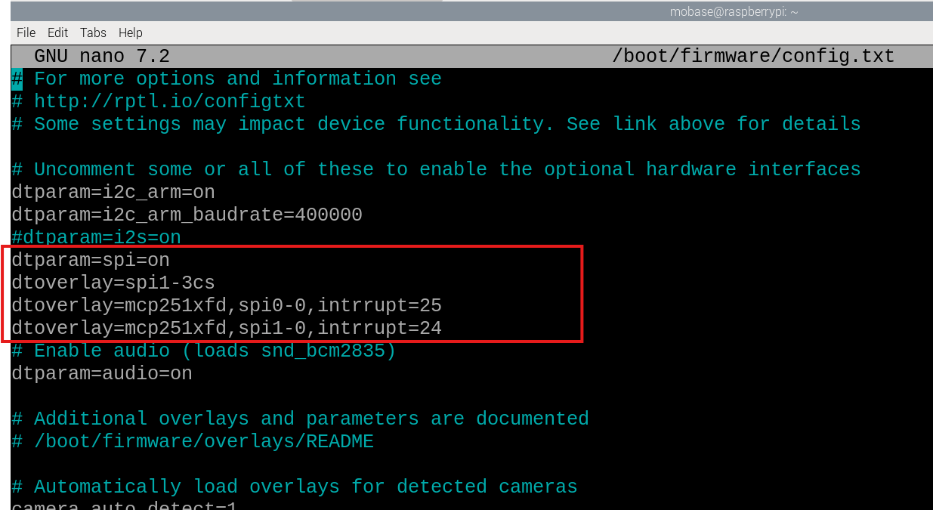

- Save the changes and exit (Press`CTRL+X`, then `Y`, then `Enter`).

- Reboot the system for the changes to take effect:
- Run the command: sudo reboot

Setting Up and Verifying the CAN_FD Interface
- Run the following commands to configure and bring up the CAN interface.
- We can activate the CAN interface and configure the CAN bus speed to 500 kbps using the command below:
Command: sudo ip link set can0 up type can bitrate 500000

- We can set the transmit queue length for the CAN interface using the command below:
Command: sudo ifconfig can0 txqueuelen 65536
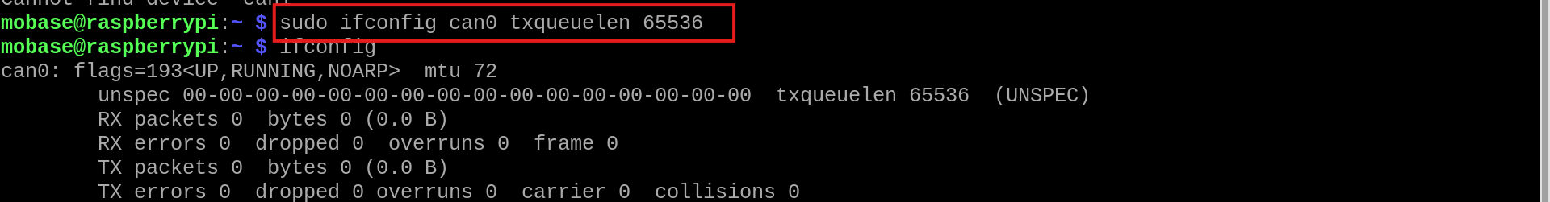

- After setup, you can check the CAN interface status with:
- We can check the CAN interface status after setup using the command below:
Command: ifconfig
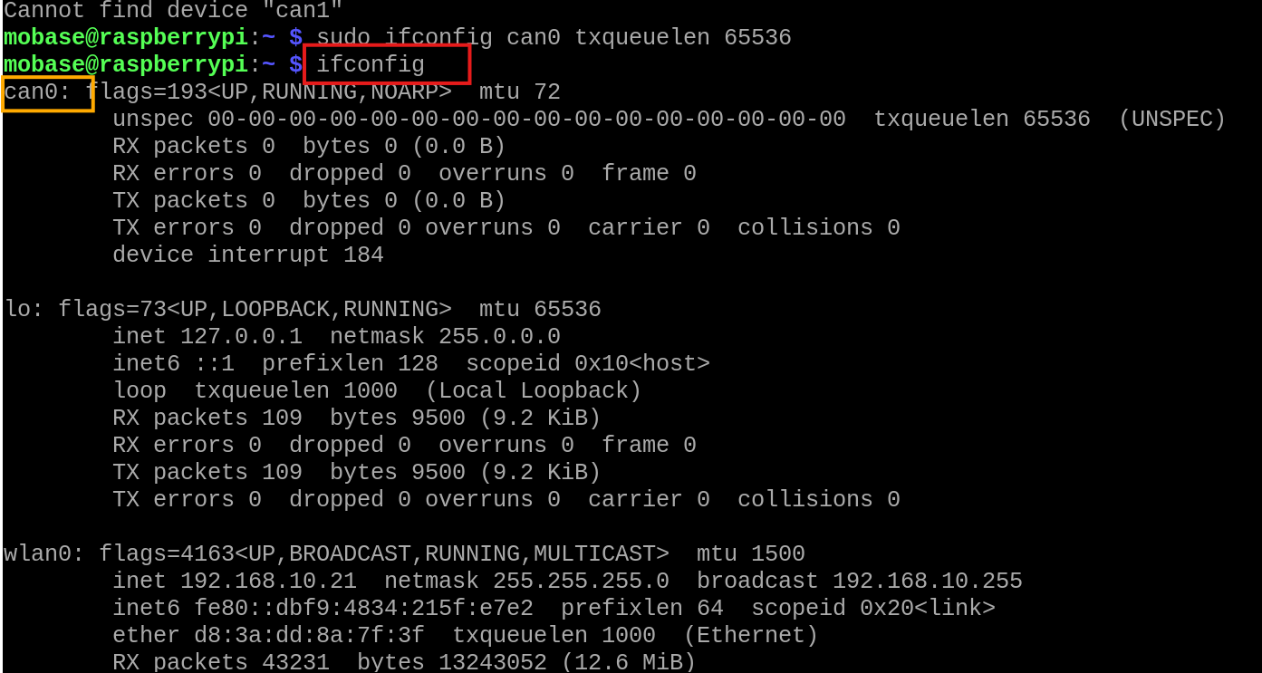
Note: For Can1 same as Can0, follow steps from 1 to 2 by replacing Can0 by Can1.

Troubleshooting Package Installation Issues
If you see externally-managed-environment error, use one of the following solutions:
- Force Installation System-Wide
- Use Virtual Environment
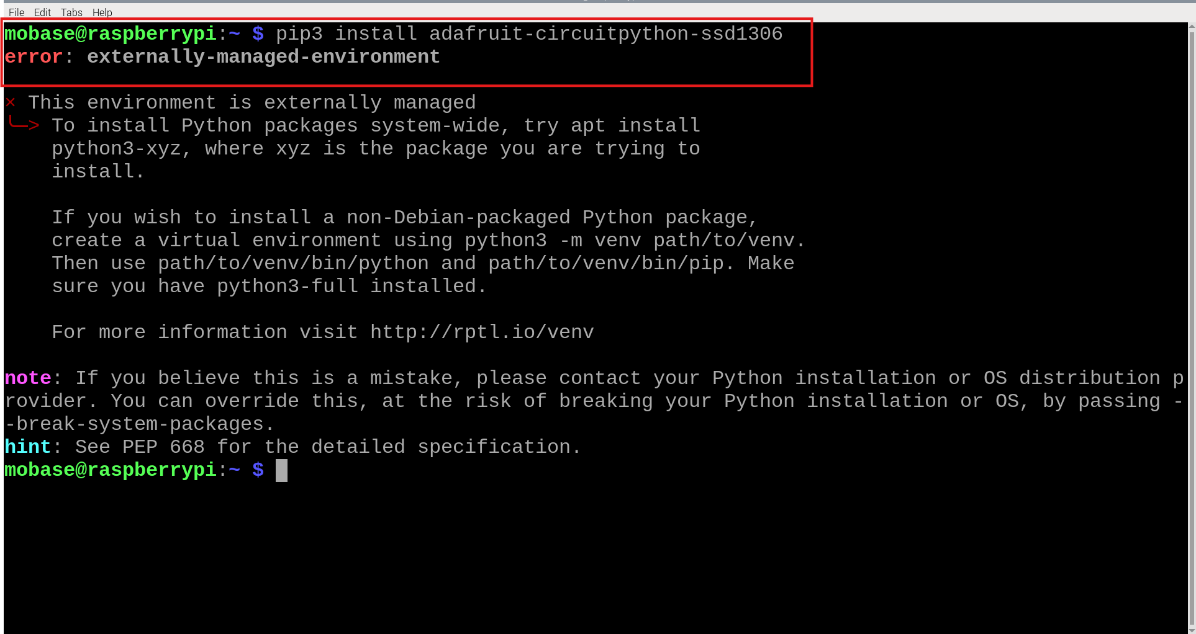

- Force Installation System-Wide
To force install, run the command pip install --break-system-packages <package-name>
For example: pip3 install –break-system-packages adafruit-circuitpython-ssd1306
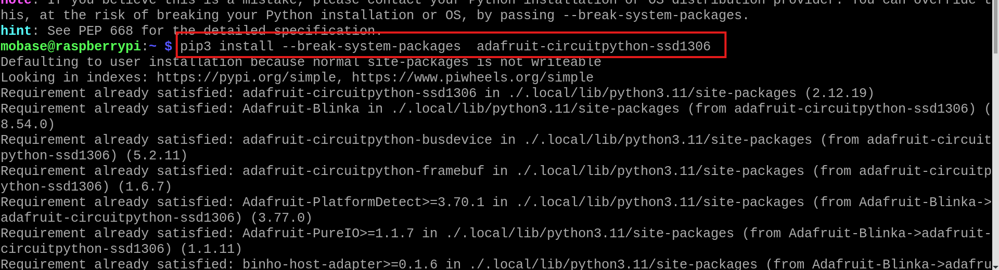

- Use Virtual Environment
Using virtual environments prevents issues with system-wide installations.
- Install virtual environment support (if not already installed):
Run the command: sudo apt install python3-venv
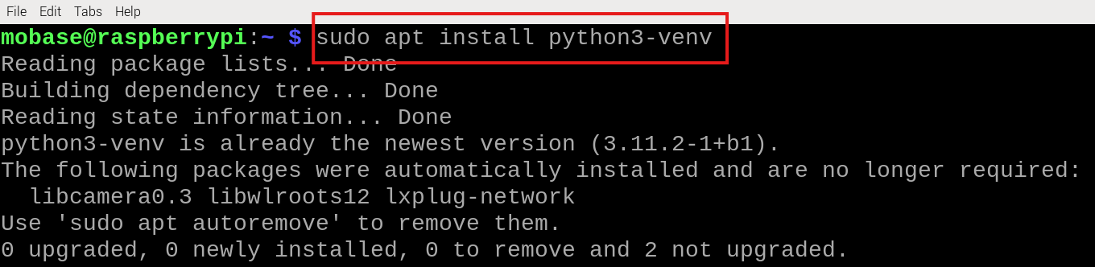
- Create a virtual environment:
Run the command: python3 -m venv folder_name
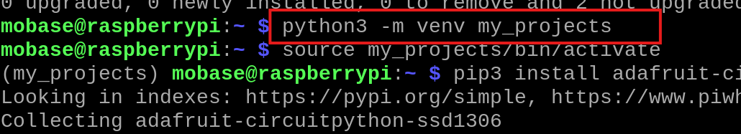
- Activate the virtual environment:
Run the command: source folder_name /bin/activate
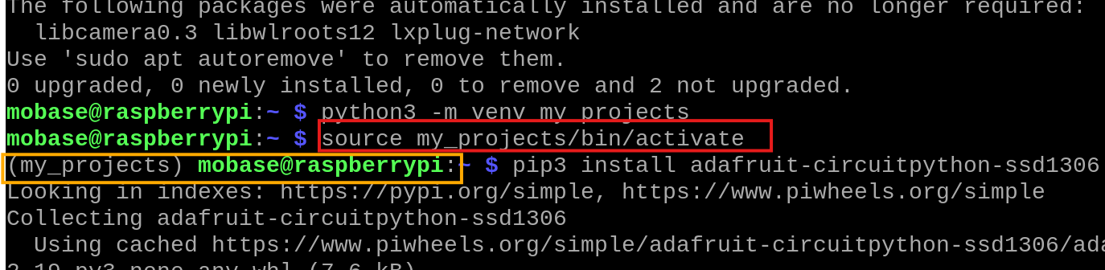
Note: After running the command, if successful, the environment's name will appear in the terminal prompt, indicating that the virtual environment is active.
- Install required libraries within the virtual environment:
Run the command: pip install <package-name>
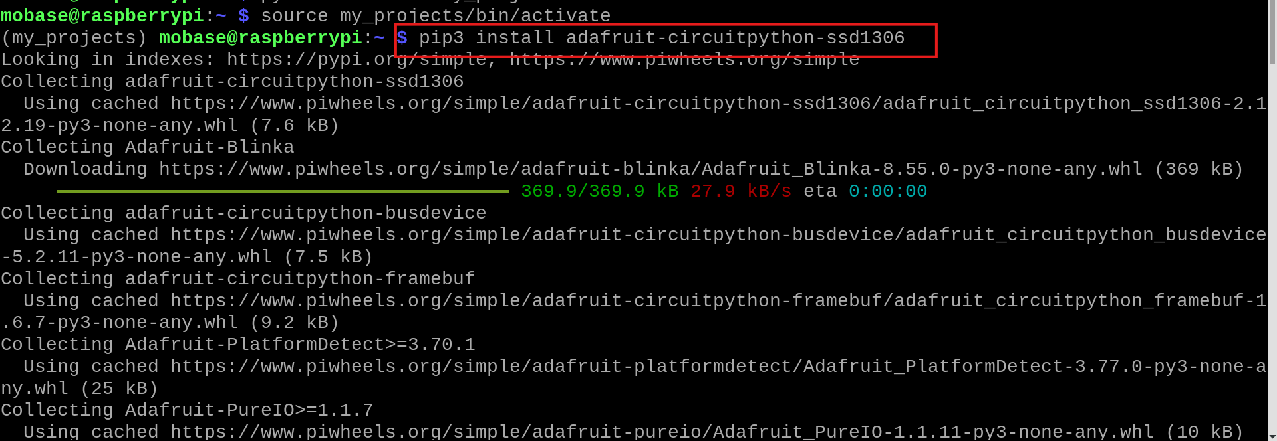
- Deactivate the virtual environment when done:
Run the command: deactivate
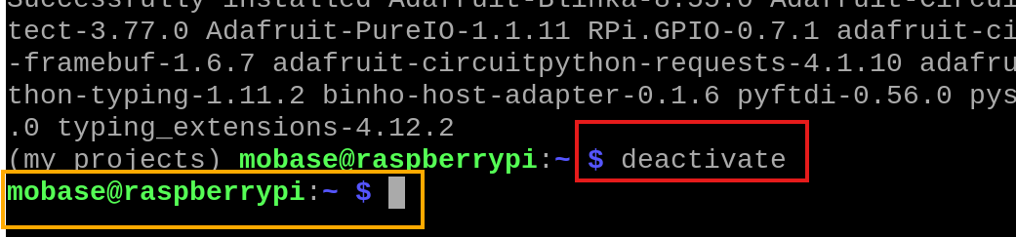
Note: After running the command, if successful, the environment's name will disappear in the terminal prompt, indicating that the virtual environment is deactivated.

Prerequisites

Install Python from Python.org
- Go to python.org, Download the latest version (e.g., Python 3.13.x).
- Run the python.exe: Click on Install Now
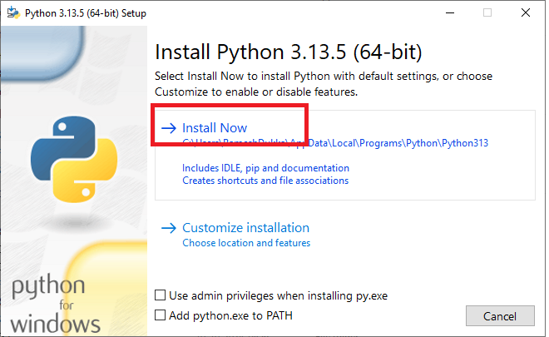
Figure 23: Python Installation
Ensure the Set up is successful.

Install Visual Studio Code (VS Code)
- To install VS Code, we need to download its installer, to download go to VS Code downloads page.
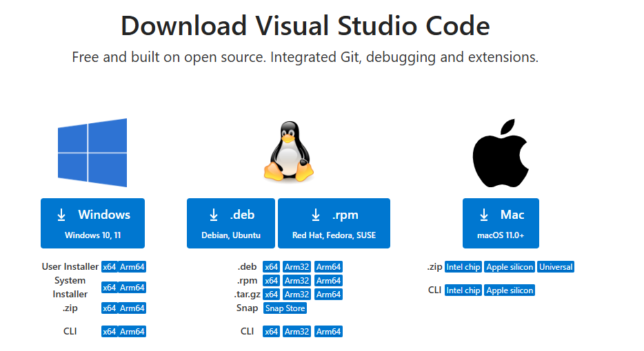
Figure 24: Download Visual Studio code
- Click on Package based on the operating system you use. As I use windows I will click on windows download button and it will start download VS Code installer.
- After the download finishes, click on the VS Code installer and it will start the setup.
- Accept the agreement, you can read it if you want and make sure you agree and click on next.
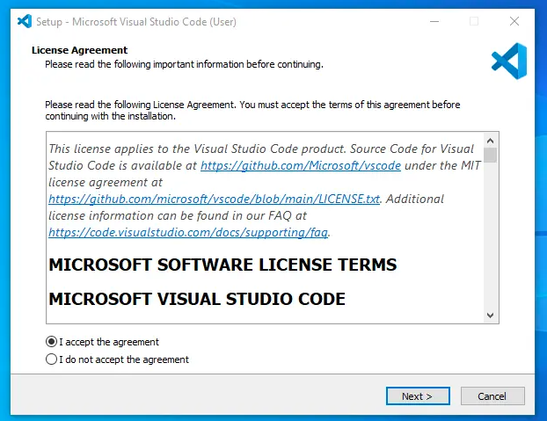
Figure 25: VS Code License agreement
- Next it pops up window to choose additional tasks, select desktop icon ,then click on next.
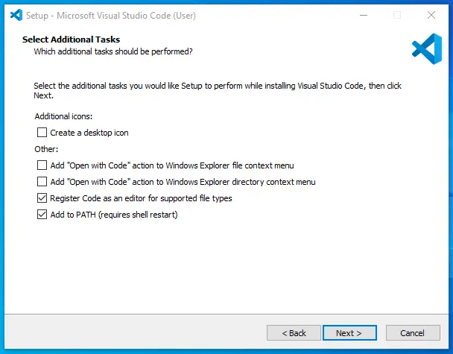
Figure 26: Setup - VS Code
- Then it will show ready to install, so click on the install button and it takes around a minute to install VS Code on your machine. After installation it show you VS Code setup completed, click on finish and it will open VS Code.

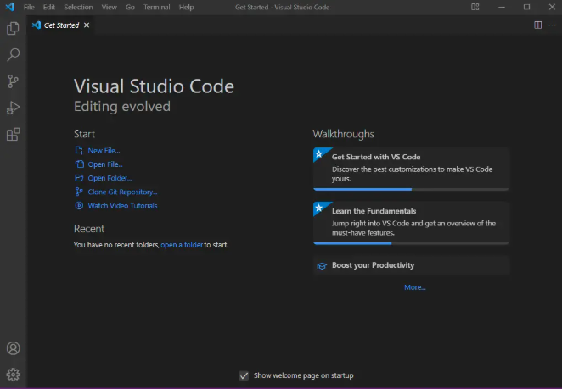
Figure 27: VS Code installed
So, VS Code is installed successfully.

Install Required Python Packages in VS Code
- Now to use python. To setup python in VS Code, we will install an extension. Open VS Code, click on the extensions tab or use ctrl+shift+x to open the extensions section, search for python, the first result display with extension Python by Microsoft. click on it and install the extension.
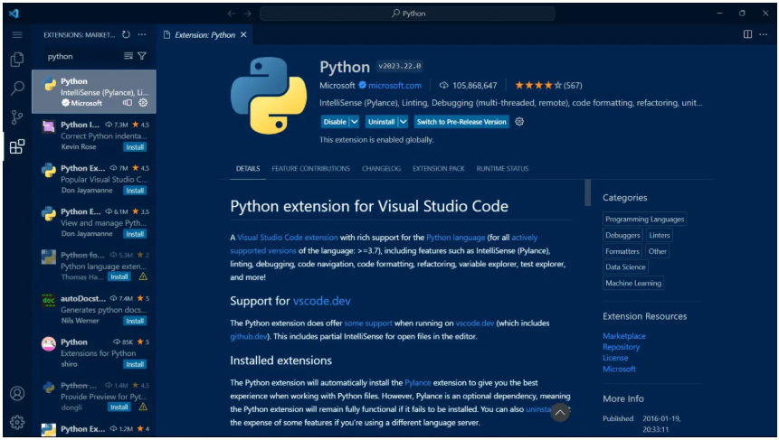
Figure 28: Python Package in VS Code

Installing pandas and openpyxl:
- In File Manager go to python.exe. The path shall be as follows:
C:\Users\YourName\AppData\Local\Programs\Python\Python3x\python.exe
Copy the path.
- Go to the VS Code Terminal, to import pandas -run the below command in Terminal as follows:
& ‘copied path’ -m pip install pandas
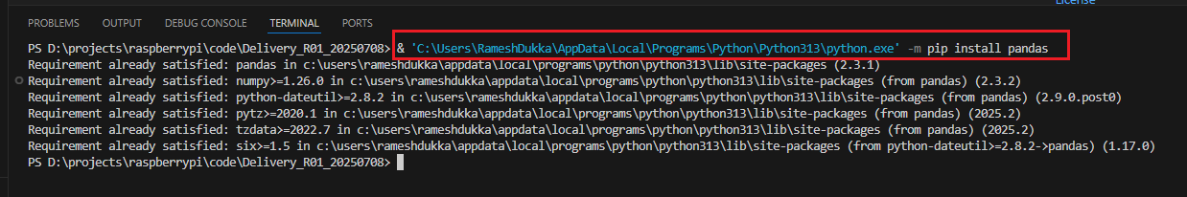
Figure 29: Pandas installation
- To import openpyxl run the below command in Terminal:
& ‘copied path’ -m pip install openpyxl
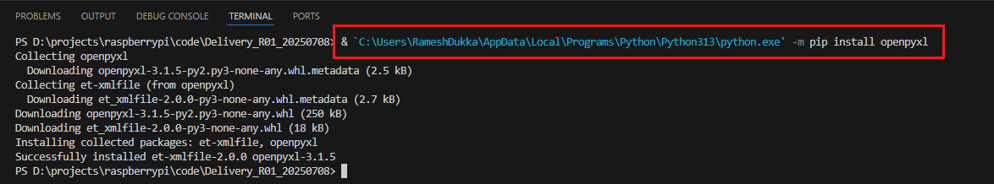
Figure 30: Openpyxl Installation

Key generation

Key Generation Server Setup for Raspberry Pi
- open following link htps://www.geeksforgeeks.org/cpp/installing-mingw-tools-for-c-c-and-changing-environment-variable/
  - Then click on link Installing MinGW Tools for C/C++and changing Environment
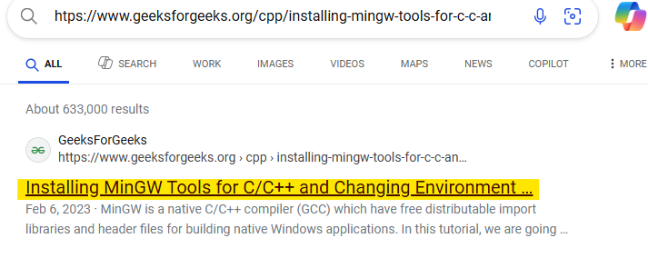

- Then you will find steps for How to Install the MinGW Tools for C/C++? and How to Change Environment Variables for MinGW

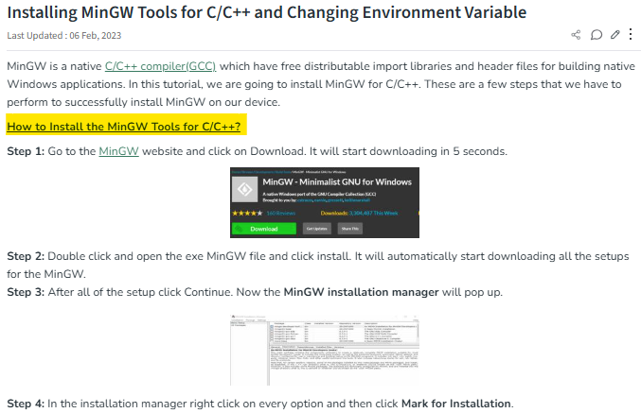

- Collect DLL file of the project and download C program code from following NAS path \\192.168.10.8\Design\Common DiagTesting\04_Repository\Server_client_Timestamp_For_Sending_Key_and_Receving_Seed_25`0609.zip
  - Keep .dll file, .c file and .h file in the same folder
- Open the downloaded .c file using Visual Studio Code. Locate the line in the code that loads the DLL
  - Make sure to provide the correct path to the required .dll file and header files also.
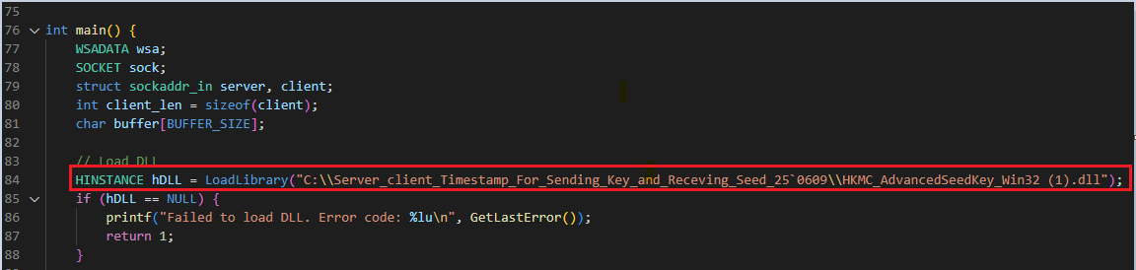

- Open Command Prompt
  - Run the following command to compile the C file and generate an executable
    - gcc -std=c99 <source_file.c> -o <output_executable_name> -I. -lws2_32
- Run the compiled .exe file from the terminal
  - Run the command: .\<filename.exe>
  - After running the executable, you should see console output like the following:
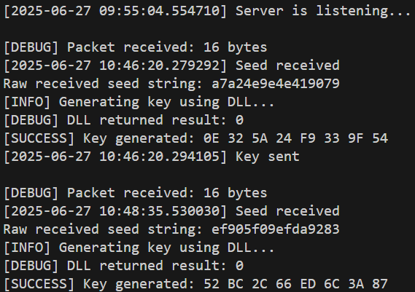

Security Access KEY generation Using DLL
For UDS Security Access, the PC's IP address must be configured in the uds_client.py script in the variable “udp_ip”.
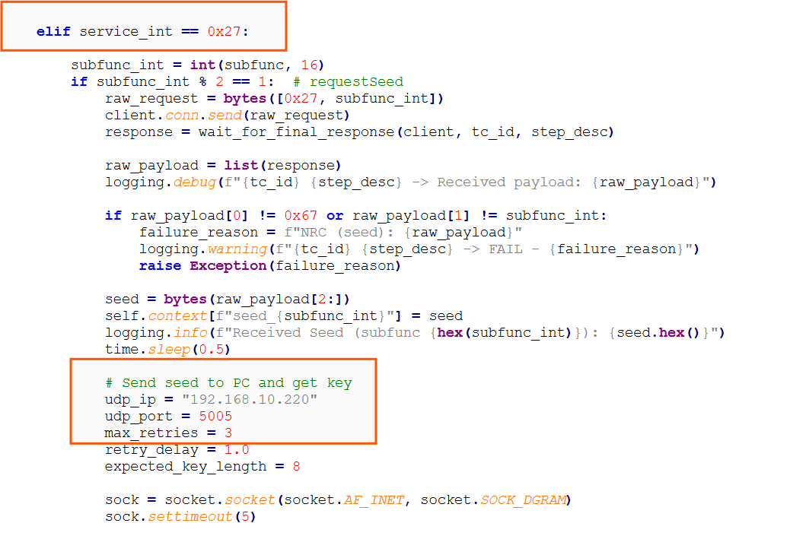

On the Windows PC side, the project-specific DLL file should be added to the designated udp_seedkey_server.c file at line 49 file, which is then compiled and executed via the Command Prompt.
When the Raspberry Pi sends a security access request (0x27 0x11) to the MKBD (ECU), it responds with a seed (0x67 0x11 xx xx). The Raspberry Pi forwards this seed to the PC using a UDP server.
The PC receives the seed, passes it to the DLL to generate the key, and then sends the calculated key back to the Raspberry Pi over UDP.

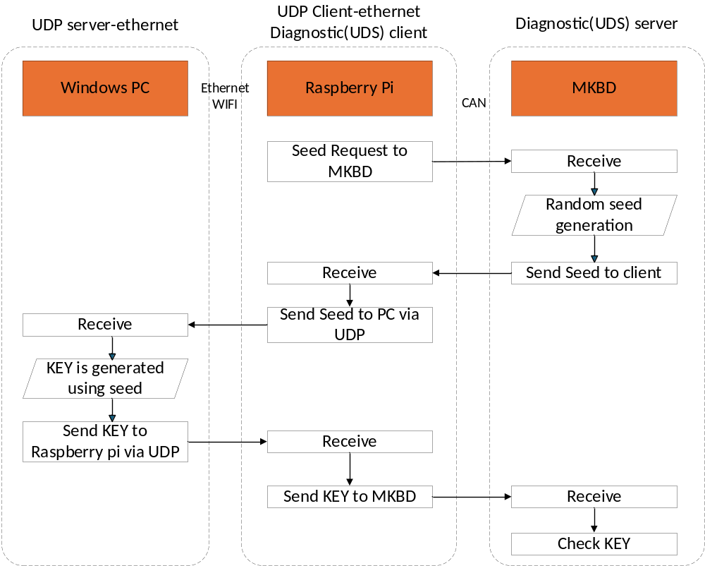
Figure 31: Security Access
Once the Raspberry Pi receives the correct key, Security Access is granted.

Hardware Set Up

Prerequisites
For setting up the Raspberry Pi hardware the necessary prerequisites are
S.NO | Component | Description
1 | Raspberry Pi Zero 2W | With pre-installed Raspbian OS
2 | microSD Card | Loaded with Raspbian OS
3 | Waveshare 2-CH CAN FD HAT Rev2.1 | SPI-based CAN transceiver
4 | Test ECU (e.g., BDC) | Connected via CAN_H & CAN_L
5 | Jumper Wires | For GPIO connections
6 | Breadboard | For easy GPIO expansion

In this setup, the Raspberry Pi Zero 2W acts as the central controller for a hardware system that includes a computer(Monitor, keyboard, mouse) and 2-channel CAN FD HAT for CAN communication, and a Test ECU (such as a BDC).
The purpose of this connection is to establish a reliable communication interface where the user can interact with the system, display relevant data, and exchange CAN messages with the ECU.
Connections are made using jumper wires and a breadboard where necessary. It is essential to follow the GPIO pin mapping exactly as outlined in the Hardware setup to ensure correct functionality. All connections should be made while the Raspberry Pi is powered off. Once the connections are verified and secured, the system can be safely powered on.

Hardware setup connections:
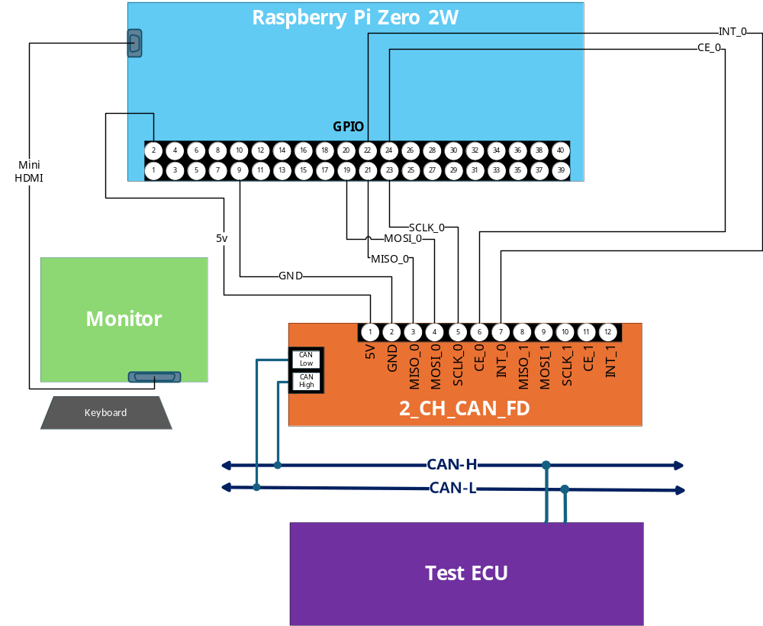
Figure 32: Hardware Setup Connections

Wiring Instructions:

2-CH CAN FD HAT (SPI Interface)
S.no | HAT Pin | Connects to Raspberry Pi GPIO
1 | 5V | Pin 2
2 | GND | Pin 9
3 | MISO_0 | Pin 21
4 | MOSI_0 | Pin 19
5 | SCLK_0 | Pin 23
6 | CE_0 | Pin 24
7 | INT_0 | Pin 22

The 2-Channel CAN FD HAT is used to enable communication between the Raspberry Pi Zero 2W and a Test ECU using the CAN protocol with Flexible Data-rate (CAN FD). This allows for high-speed, reliable message transmission between embedded control units.
Connect CAN_H and CAN_L of CAN FD module to ECU CAN bus.
Connect Keyboard and mouse to raspberry pi using USB cable.

Initial setup

Transfer source Code from USB to Raspberry Pi:
Insert the USB flash drive into one of the Raspberry Pi's USB ports. As soon as USB is connected below prompt will open.
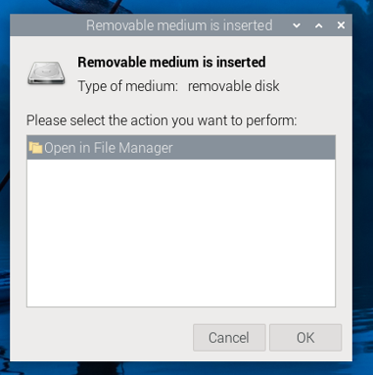
Figure 33: USB Connected prompt
Click “ok” to proceed.
Copy the source code with folder named as UDS_Tool_Raspberry_Pi into Raspberry Pi using USB flash drive.
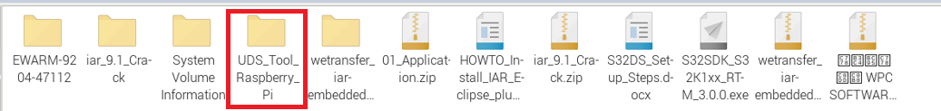
Figure 34: Copy Source code into RaspberryPi
UDS_Tool_Raspberry_Pi having following Folder structure
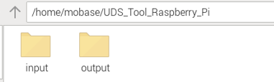
Figure 35:Source code folder structure
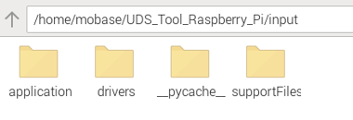
Figure 36: Input folders content
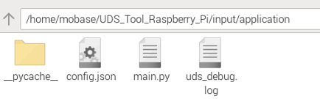
Figure 37: Main.py in Application folder
Application folder consists of main.py ,double click on the main.py and the file will be opened in the tool.
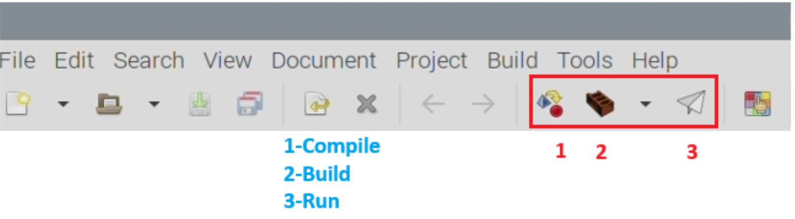
Perform following steps
- Compile
- Build
- Run to execute application

User Procedure

System Overview:
When the diagnostic application is executed from command prompt, it provides a menu interface and interacts with the user.

Testcase Selection:
Testers need to select required services from database (Excel sheet). Preconditions specified in that service also need to be selected as shown in the image below:
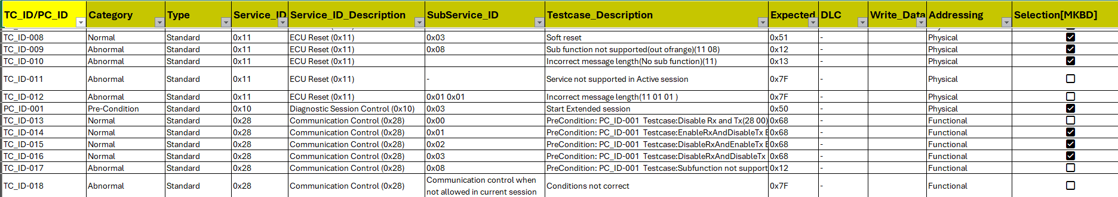
Figure 38: Services Database
After selection of testcases, a python script is run to generate a .txt file containing only the required services.
testcase.txt file generated in path:
/home/Mobase/UDS_Tool_Raspberry_Pi/input/supportfiles/testcase.txt

UDS Config Editor To edit Config.json file:
1. Open UDS_Config_Editor.exe located at:
Automate_JSON_file_Config_Parameters_R01/UDS_Config_Editor.exe
2. Click on "Select JSON Config File" and navigate to the previous configuration file path:
Common_Diagnostics_RaspberryPi_CANFD_R01_25'0728/input/application/config.json
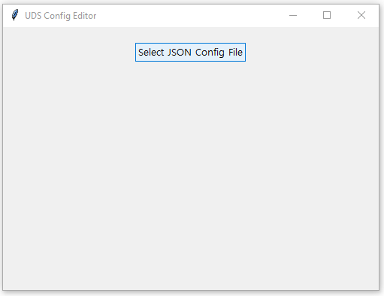
Figure 39: UDS Config Editor
3.Edit all required parameters as needed.
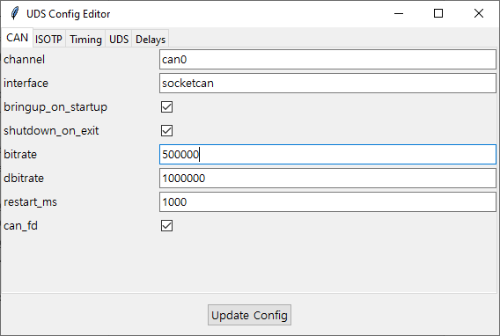
Finally, click on "Update Config" to save your changes.

Display and User Interaction:
- A service menu is shown on execution of main application in the command prompt.
The menu allows input through keyboard.
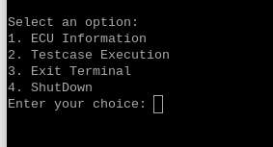
Figure 40: Menu in command prompt

- Based on the selection, the system displays the selected service (e.g., Read ECU Info, Run Test Cases).
- It shows real-time execution status of selected test cases.
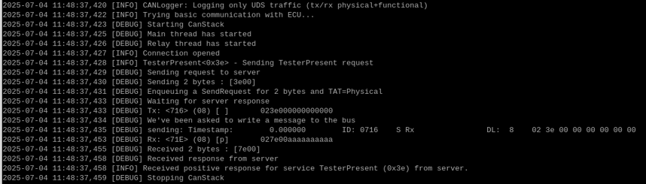
Figure 41: Execution status

Testing Logs and Test Report
CAN Logging:
CAN logging starts automatically once the input is given from keyboard and stops once all test cases are executed successfully.
Logs are saved in .asc format (ASCII log file), by following naming convention as mentioned. (i.e., can_log_YYYYMMDD_HHMMSS.asc)
Logs storing in the following path: /home/Mobase/UDS_Tool_Raspberry_Pi/output/can_logs.
Test Report Generation:
A HTML report is automatically generated after test cases are executed.
The test report contains basic information such as target ECU, version details etc, as shown below:
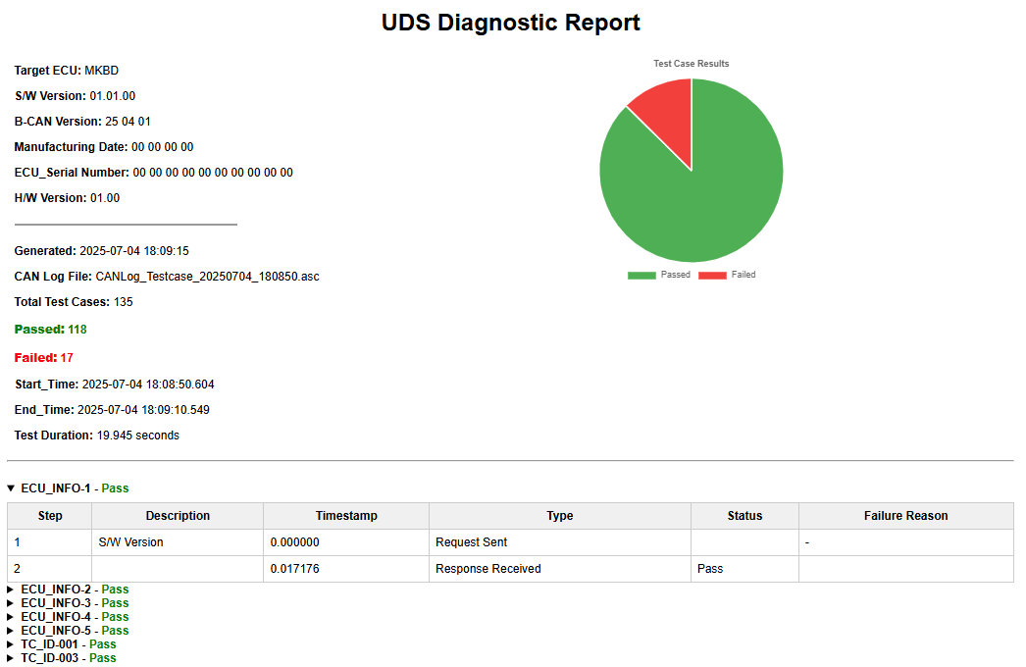
Figure 42: UDS Diagnostic report

The report uses an accordion-style layout, allowing users to expand each test case for a detailed step-by-step view.
Test Report naming convention is as follows: UDS_Report_<timestamp>.html
Test Report stored in following path: /home/Mobase/UDS_Tool_Raspberry_Pi/output/html_reports

Debug log file:
A debug log file is generated parallelly along with can log file. This contains all the information on what exactly happened while executing the test cases. Refer below image:
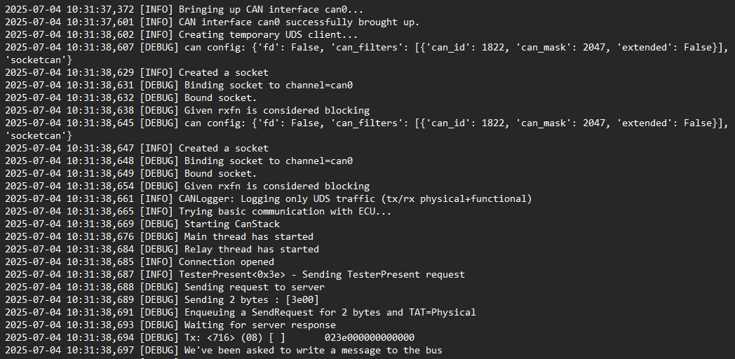
Figure 43: UDS Debug log file
Debug log file is stored in the path:
/home/Mobase/UDS_Tool_Raspberry_Pi /application/

Change History
Date | Ver. | Chapter | Editor | Description | Note
25’02/27 | 1.0 | All | Sagar/ Prudhvi Raj | Initial Document | -
25’04/28 | 2.0 | 4 | Sagar/ Prudhvi Raj | Updated Package installation procedure | -
25’04/29 | 3.0 | 5 | Sagar/ Prudhvi Raj | Updated Hardware Setup | -
25’03/02 | 4.0 | 6&7 | Sagar/ Prudhvi Raj | Added Initial setup/User Procedure | -
25’07/04 | 5.0 | 4,5,6,7,8 | Sagar/ Prudhvi Raj | Updated the below info  - Monitor, keyboard setup instead of OLED.  - Key Generation Server Setup for Raspberry Pi | -
25’07/29 | 6.0 | 5 | Sagar/ Prudhvi Raj | Added information on Installation of Python, VS Code, Pandas and openpyxl. | -
25’08/01 | 7.0 | All | Sagar/ Prudhvi Raj | Updated the document with new template | -
25’08/07 | 8.0 | 9.3 | Sagar/ Prudhvi Raj | Updated the UDS Config Editor | -

-End Of Document-

